**COMPUTER NETWORKS**

**MODALLA PRANITH REDDY 2420030158**

**LAB 1**

**Introduction to the laboratory and the tool used: Cisco Packet Tracer**

**Step 1:**Visit the official website of [Netacad](https://www.netacad.com/) using any web browser.



**Step 2:**Press the login button and select log In option.



**Step 3: The** Next screen will appear, click on the sign-up option.

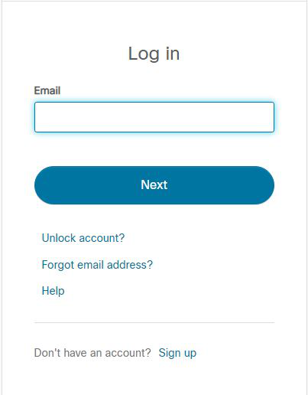

**Step 4:** The Next screen will appear and will ask for email and password, and other simple details. Fill them in and click on Register.

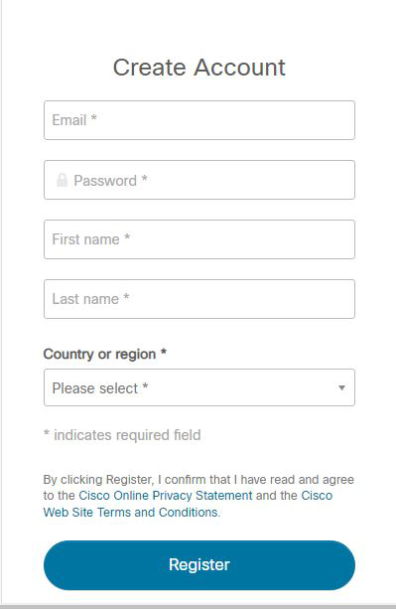

**Step 5:**Now the login screen appears again, so fill in your email ID.

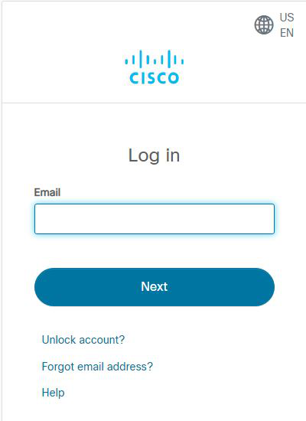

**Step 6:**On the next screen, enter the password and press the Login button.

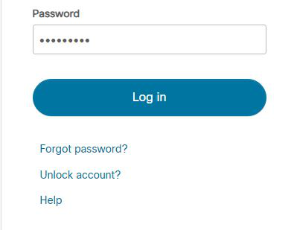

**Step 7:**Dashboard will initialize. Now, click on Resources and choose Download Packet Tracer Option.

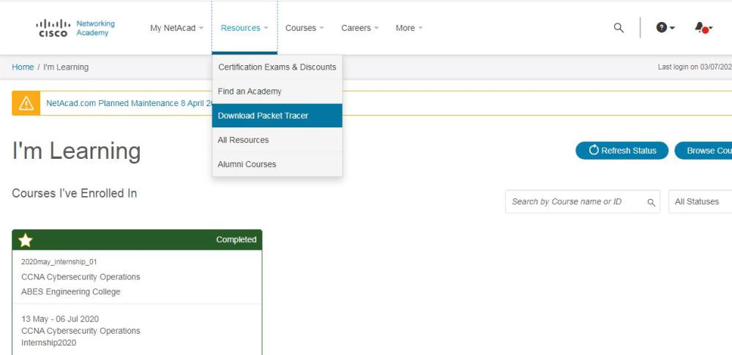

**Step 8:**On the next web page, choose the operating system to download the Packet Tracer. Downloading will start automatically.

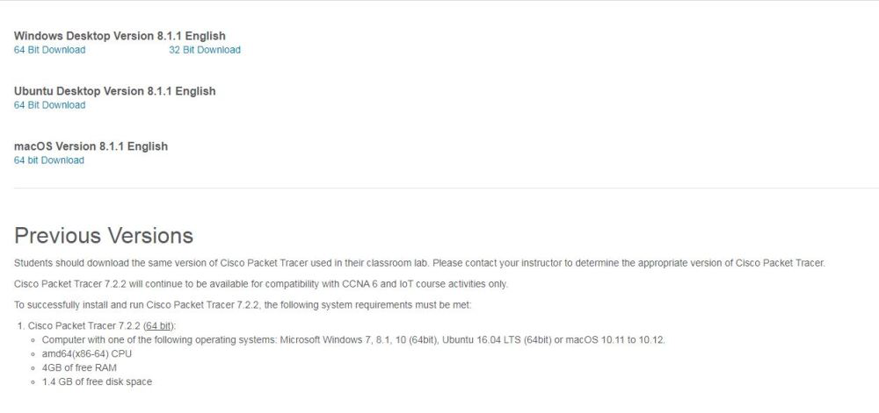

**Step 9:**Check for the executable file in your system and run it.

**Step 10:**Next screen is of License Agreement, so click on **I accept** the license.

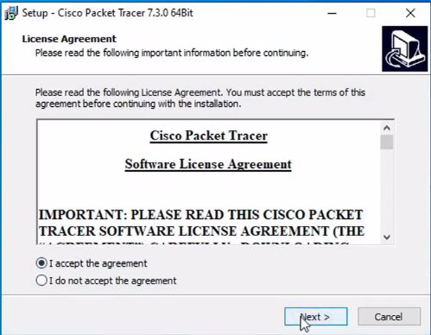

**Step 11:**Choose the installation location that has sufficient space.

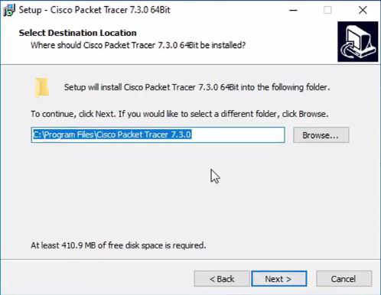

**Step 12:** Select the Start menu folder and click the **Next** button.

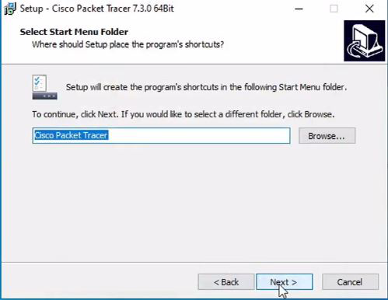

**Step 13:**Check the box for creating a desktop icon and click on the **Next** button.

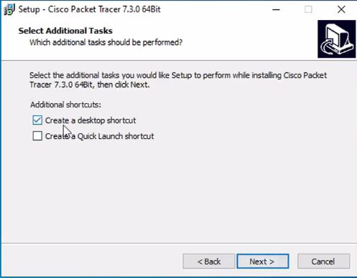

**Step 14:** Now, Packet Tracer is ready to install, so click on the **Install**button.

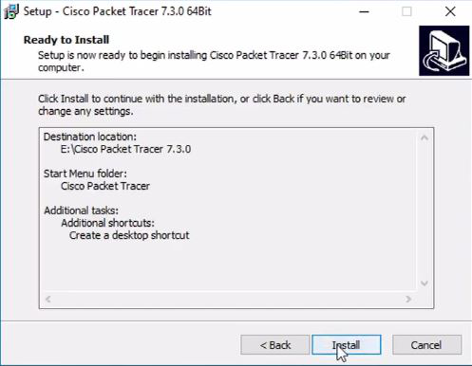

**Step 15:**The installation process will start and will hardly take a minute.

**Step 16:**Click on the **Finish** button to complete the installation.

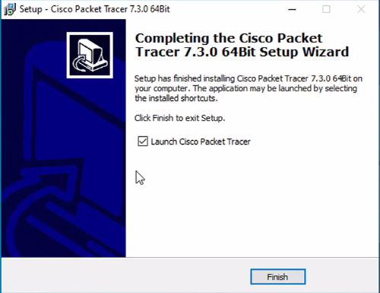

**Step 17:**An icon is created on the desktop, so run it.



**Step 18:** The Interface is initialized, and the software is ready to use.

